Registered Charity 1091206  Incorporated under the Companies Act 1985  Company No 4197657  VAT No - 162 4540 25 | 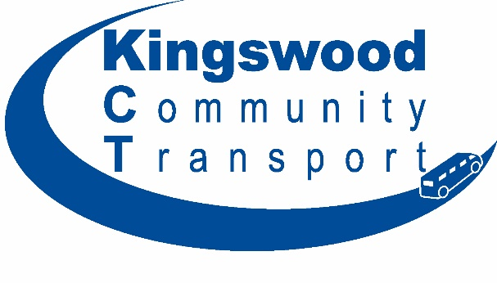 | No 2 Office  Old School House  Britannia Road  Bristol  BS15 8DB  Tel: 0117 9616016  Web www.kingswoodct.org.uk  Email info@kingswoodct.org.uk

Standard terms and conditions

Group hire charges without driver are as follows;

 | Mini-Bus  (12 - 16 seater) |  | Car  (4 seater)
 | Group | Youth | Group | Youth
Full Day and evening Hire | £89.00 | £44.50 | £37.00 | £21.00
Half Day | £44.50 | £22.25 | £18.50 | £10.50
Weekend Hire | £175.00 | £87.50 | £74.00 | £36.00
Two Days > | Please contact the office for the hire charge

Fuel Charges
First 50 miles | 75p pm | 50p pm | 60p pm | 40p pm
Each Mile After | 40p | 35p | 35p | 35p

Fuel Charges

If request for full tank and return with full tank there will be a surcharge of £6 per day (part & whole). If not returned fully fuelled, the following charges will be applied to the invoice, cost of the fuel and a £10 charge to cover our administration costs and the expense of refuelling.

All school hire is at the group hire rate.

Kingswood Community Transport can provide a volunteer driver for your use.

There will be a charge for this to cover their expenses;
- Weekday up to three hours - £5.00
- Weekday up to five hours - £6.50
- Weekday over five hours - £10.00
- Saturday or Sunday volunteer expense - £15.00

Volunteer expense rates will be agreed at the time of booking.

You can drive our vehicles yourselves as long as the person doing so has undergone MiDAS (Mini-bus Driver Awareness Scheme) training and holds a valid certificate. You will be required to present a valid MiDAS certificate to us at the time of picking up your vehicle. Failure to present a valid certificate will result in no vehicle being provided.

The hirer is responsible for the care of the vehicle during your hire period and will be provided to you in a clean and smart manner.

If the vehicle is involved in an incident and requires repairs the hirer will be liable to the first - | £250
If the vehicle requires cleaning on your return, we reserve the right to levy a cleaning charge. | £20
If you cancel your Group Hire within 36hours of the start time of your trip you will incur a cancellation fee | £30

The cost of your hire may be reduced if the passengers that you are carrying possess a South Gloucestershire Council Diamond Travel Card (Bus Pass). Details of possible reductions will be agreed at the time of booking. Hirers are responsible for providing lists of the passengers they carry. Pick up lists for passengers should be provided as soon as possible but no later than the date of your travel or you will be charged the full hire rate without any reductions that maybe applicable.

Invoices are issued the day after the hire unless further hires are due that month and payment requested to be made within 30 days.

